Project Design Phase-I
Solution Architecture
Date | 25 August 2026
Team ID | N/A
Project Name | HouseHunt
Maximum Marks

Solution Architecture:
Solution architecture is the bridge between the business problem and the technology solution. Its goals are to find the best tech solution for the problem, describe the structure, characteristics, and behaviour of the software, define its features, development phases, and delivery, and provide specifications for how the solution is built and managed.
Architecture Diagram:
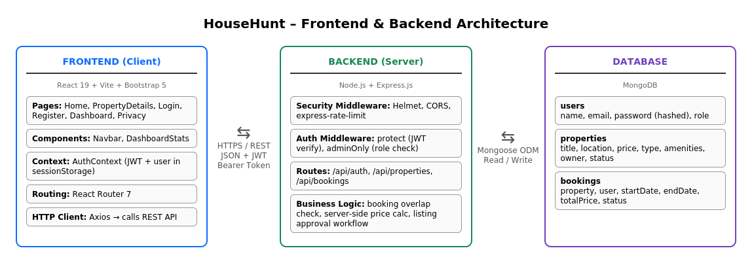
Fig No : 01 HouseHunt Frontend, Backend & Database Architecture
Data Flow through the Architecture:
- 1. Client: Tenant, landlord, or admin uses the React 19 + Vite single-page app (Home, PropertyDetails, Login/Register, Dashboard).
- 2. Request: The app calls the REST API over HTTPS with JSON; the JWT is sent as an Authorization: Bearer token.
- 3. Security middleware: Helmet, CORS allowlist, and rate limiting screen every request.
- 4. Auth middleware: protect verifies the JWT; adminOnly checks the admin role for moderation routes.
- 5. Business logic: Route handlers (/api/auth, /api/properties, /api/bookings) apply the booking overlap check, server-side price calculation, and listing approval workflow.
- 6. Database: Mongoose reads and writes the users, properties, and bookings collections in MongoDB and the result returns to the client.

